
Work Instruction for DRS Settings for Pacemaker Cluster

Viatris
Work Instruction for
DRS Settings for Pacemaker
Cluster

Contents
Contents 2
1. Introduction 3
1.1. Purpose 3
1.2. Scope of this Report 3
1.3. Audience 3
1.4. Definitions 3
2. Approach and Methodology 4
2.1. Approach 4
2.2. Methodology 4
3. Technical Details 4
3.1. Step 1 4
3.2. Step 2 5
3.3. Step 3 6
4. Roles and Responsibilities 6
5. Escalation Matrix 7
6. Related Documentation 7
6.1. Additional Documentation 7
7. Version Control 7

1. Introduction

1.1. Purpose
This document describes how to modify DRS settings in VCenter for Pacemaker Cluster Nodes.

1.2. Scope of this Report

The custom DRS settings should be added during Pacemaker cluster build.

The Custom DRS settings can be applied only for OS cluster participating Nodes (VM)
1.2.3 This custom DRS settings must be captured in Pacemaker cluster build Change or Related CTASK.

1.3. Audience
GIDC Unix Group

1.4. Definitions
    - DRS: VMware vSphere Distributed Resource Scheduler.
    - VM: A Virtual Machine (VM) is a compute resource that uses software instead of a physical computer to run programs and deploy apps.
    - Host: The virtual representation of the computing and memory resources of a physical machine running ESX Server.
    - Pacemaker: An open-source high availability resource manager software used on computer clusters.
    - VCenter: The centralized management utility for VMware.

2. Approach and Methodology

2.1. Approach
[Provide a brief description of the approach followed for performing the procedure]

2.2. Methodology

3. Technical Details

3.1. Step 1
    - Login to vCenter with SADM account.
    - Browse to the cluster in the vSphere Web Client navigator.

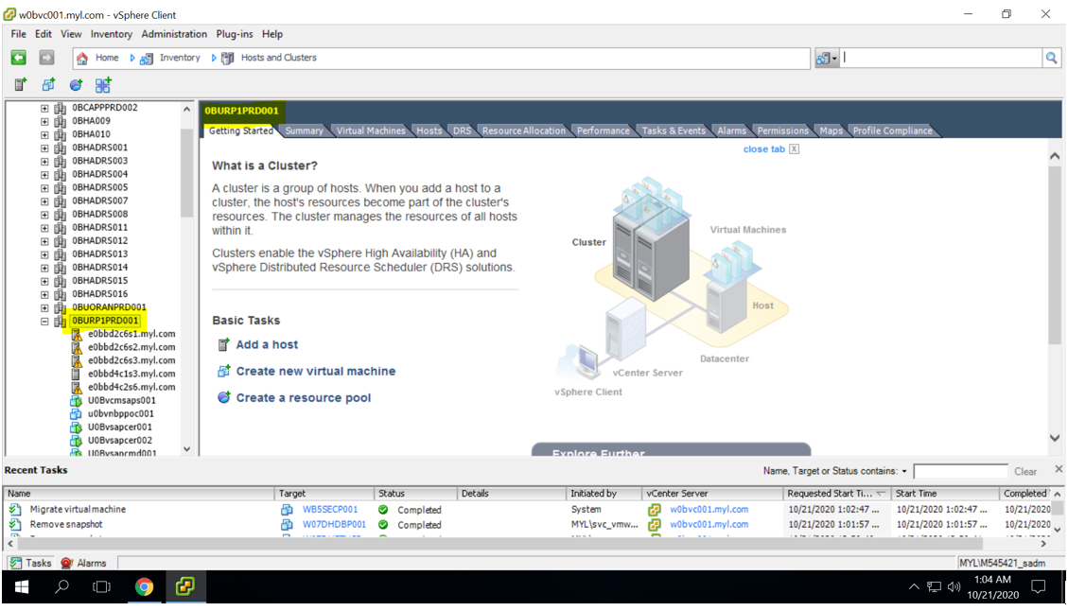

3.2. Step 2
    - Right Click the Cluster and Click Edit Settings
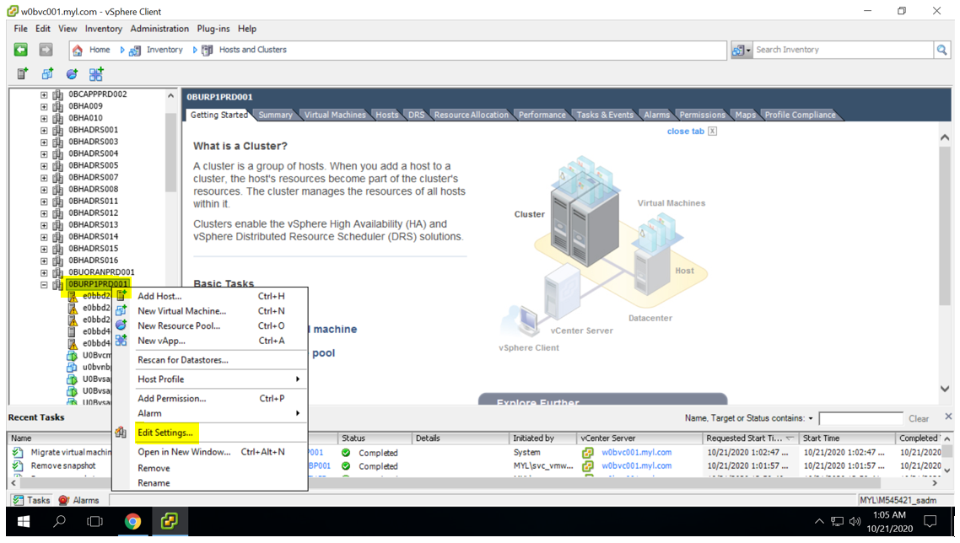
    - Click Virtual Machines Options under vSphere DRS
      - Search the VM name under the Virtual Machine or Automation Level Contains tab.
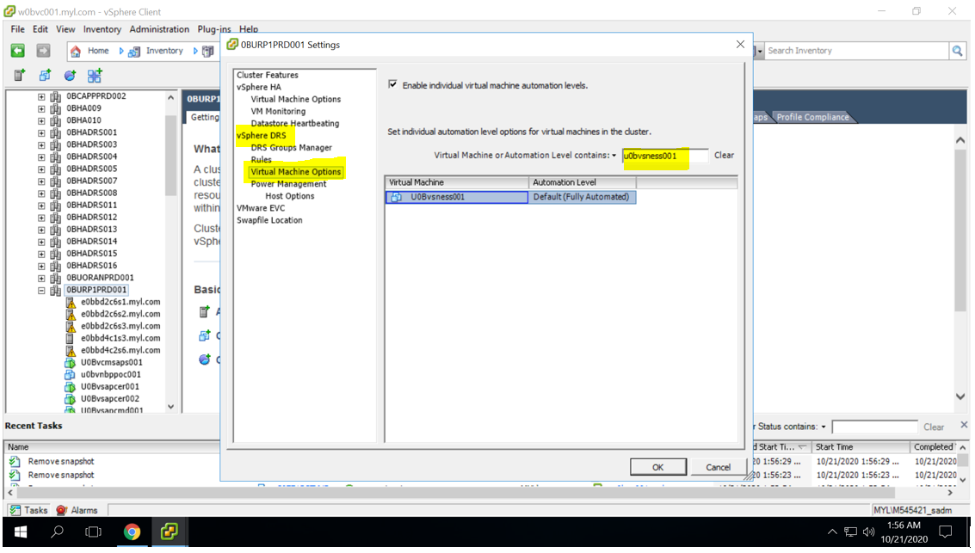

3.3. Step 3
    - Select drag down option under the Automation Level and change it to Manual and click ok.
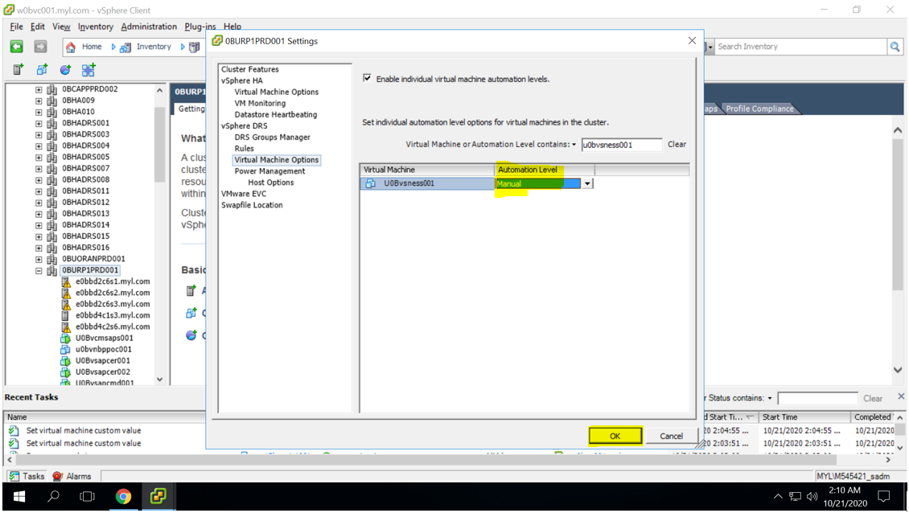

4. Roles and Responsibilities
Sl. No. | Roles | Responsibilities | Team Member Name
1. | Maintenance Window | Respective Team / Unix Team | GIDC.unix_Run  GIDC.unix_Run@viatris.com
2. | Change Request | Respective Team / Unix Team | GIDC.unix_Run  GIDC.unix_Run@viatris.com
3. | Change Implementation | Respective Team / Unix Team | GIDC.unix_Run  GIDC.unix_Run@viatris.com
4. | Hyper Care | Respective Team / Unix Team | GIDC.unix_Run  GIDC.unix_Run@viatris.com

5. Escalation Matrix
Person Responsible | Role | Triggers When
Arun R  Arun.R@viatris.com  +91 9710677240 | SME
Ashok Kumar R K  AshokKumar.RK@viatris.com  +91 9967735890 | Manager
Mohandoss Murugesan  Mohandoss.Murugesan@viatris.com  +91 6366966170 | Senior Manager

6. Related Documentation

6.1. Additional Documentation

7. Version Control
Date | Version | Summary of Changes | Author | Approved by
May 19 2021 | V1.0 | Updated Organization Detail | Franklin Kabila Dhas | Arunachalam G
Apr 5 2023 | V1.1 | Updated in New Template | Ashok Kumar RK | Mohandoss Murugesan
Dec 28 2024 | V1.2 | Validated the Document | Benesh Selva Nesan P | Arun R

